HALİLLER PRIMARY SCHOOL
2nd TERM 3rd examination draft for 8th by ATİLLA KADAK ©

1. Aşağıdaki cümleleri , BE ABLE TO modalını kullanarak yeniden yazın:
a. I can’t understand the lesson.
_______________________________________________ .
b. I can’t swim in a pool.
_______________________________________________ .

2. Aşağıda verilmiş olan öneri ve teklif cümlelerini uygun olarak istediğiniz gibi tamamlayın ( fiil yapılarına dikkat edin )
a. Let’s __________________________________________ .
b. How about ____________________________________ ?

3. Aşağıda verilmiş olan cümleleri tamamlayın, ayrıca son iki soruyu da yanıtlayın : .
( örnekteki gibi : « Antalya is in the south of Turkey » )
- İzmir is _____________________________________ .
NAME
NUMBER |  | SCORE
- Ankara and Kayseri are _______________________ _____________________ .
- Where is Sinop ?
___________________________________________
- Where are Muğla and Antalya ?
___________________________________________

4. Aşağıda şekle bakarak soruyu yanıtlayın :




sports center
cafe
bank
school
Jimmy’s house

HOW CAN I GET TO JIMMY’S HOUSE ?
First,______________________________________________
___________________________________________________
___________________________________________________
___________________________________________________
___________________________________________________

5. Yukarıdaki şekle bakarak aşağıdaki boşluklara uygun PRE-POSITION ’ları yazın :

- The bank is ________________ the sports center
- The cafe is ________________ the school.
- The school is ______________ the bank and the cafe.
- The bank is _____________ the school.

6. Aşağıdaki sorulara RELATIVE CLAUSE ‘ ları kullanarak yanıt verin :
- What is a parrot ?
______________________________________________
_______________________________________________

- Who is a teacher ?
______________________________________________
_______________________________________________ .

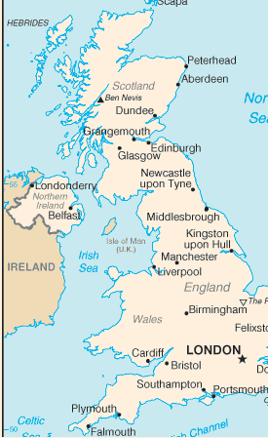
7. Aşağıdaki cümlelerdeki boşluklara uygun LINKING VERB’leri yazın:
- These tulips __________ wonderful.
- My mother is ill. She___________ terrible.
- Your girl friend ____________ very beautiful.
- This cake doesn’t ___________ delicious at all

8.Simple Future Tense (basit gelecek zaman) da verilmiş olan sorulrı yanıtlayın.
  - What will you do tomorrow?
______________________________________________
_____________________________________________
  - Where will you go next week?
_____________________________________________
  - Shall we leave the class in 30 minutes?
_____________________________________________
  - Will your mother make a cake this week?
_____________________________________________

POINTS :
4th question = 12 points
all others questions = 4 points

GOOD LUCK TO ALL …

copyright © atilla_kadak@hotmail.com

